Ju fad

Investing in rural people

WFP

31 August 2021



Dear Ms. Hayward,

This letter is to serve the purpose of the "Letter of readiness from the preferred Supervising Entities" to be included in the Global Agriculture and Food Security Program (GAFSP) submission package that the Government of the Lao People's Democratic Republic (Lao PDR) intends to present to the GAFSP Secretariat in response to the 2021 Call for Proposals for Country Submissions.

The International Fund for Agricultural Development (IFAD) and the World Food Programme (WFP) have discussed the proposal with the Government of Lao PDR, and support the submission of the proposal prepared by the Government.

The IFAD's current agriculture portfolio in Lao PDR includes the Strategic Support for Food Security and Nutrition Project funded by GAFSP (AFN I - GAFSP, US$ 25.5 million) and the Partnerships for Irrigation and Commercialisation of Smallholder Agriculture Project (PICSA, US$ 85.3 million). The WFP's portfolio includes among others, the Strategic Support for Food Security and Nutrition Project funded by GAFSP (AFN I - GAFSP, US$ 8.3 million) and the USDA funded McGovern- Dole International Food for Education and Child Nutrition Program, US$ 25 million).

The AFN- I project was rated 1 (the highest rating) in the June 2021 GAFSP portfolio review. The impact survey conducted in the project areas also confirm the high performance of the project. The midline survey found that household income increased by over 56% in project areas, the share of households below the poverty line fell from around 70% to below 50%, and women were consuming healthier and more diverse diets.

The proposed AFN-II Project will build on the lessons learned and the evident achievements of the above-mentioned AFN-I, which is ending in December 2022. The proposed Project intends to start in December 2022 and end in December 2027. The project will build on GAFSP funding of $20 million as per this submission package and additional financing from IFAD of up to $20 million (given this will be a loan, this is subject to final negotiations with the government). The first disbursement from the Supervising Entities to the country is estimated in Quarter 1 of 2023, depending on the conditions stated in the Financing Agreement.

The submission package also represents a scaling up of the partnership between IFAD and WFP, two of the Rome-Based Agencies, the UN agencies focused on food and agriculture and the proposed project will receive the full support of both organizations. —)

International Fund for Agricultural Development Via Paolo di Dono, 44 00142 Rome, Italy Tel.: +39 06 54591 Fax: +39 06 5043463 E-mail: [ifad@ifad.org](mailto:ifad@ifad.org) Web site: [www.ifad.org](http://www.ifad.org)

In light of the above, we are pleased to confirm the IFAD and WFP's readiness to serve as Supervising Entities for the above-mentioned proposal in the event of its acceptance for funding by the GAFSP.

Please allow us to take advantage of this opportunity to thank you for your trust and continued collaboration.

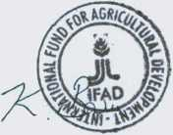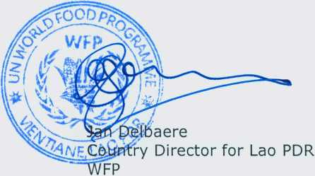Sincerely,

Kaushik Barua

Country Director for Lao PDR

IFAD

To:

Ms. Natasha Hayward

Program Head

Global Agriculture and Food Security Program (GAFSP) Coordination Unit The World Bank Group